**FUNCTIONAL REQUIREMENTS AND CASES OF USE**

*“Example is always more efficacious than precept” Samuel Johnson*

**UMLDIAGRAM**

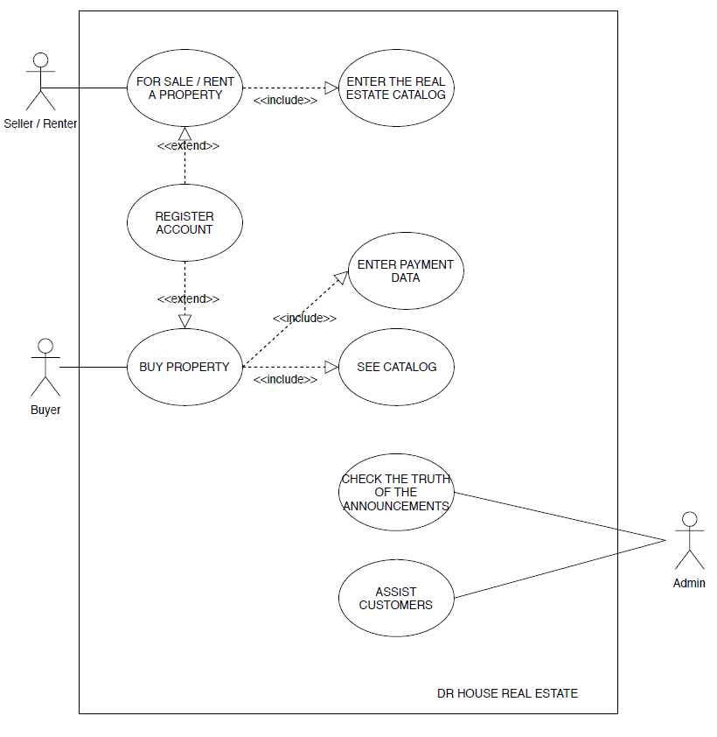

**USE CASES**

**Name**: Subscribe

**ID**: CU1

**Preconditions**: the user has a property to sell or to buy

**Main sequence:**

1. The use case begins when the customer selects the ‘registered’ item from the menu

2. The user is redirected to the appropriate page with the relative registration form

3. The user enters the requested data

4. The system registers the user based on the specifications entered

**Alternative sequences:**

In point 3, if the data entered are not valid, the system asks for the correct data to be entered.

In point 3, if the required data are missing, the system stops until they are entered.

-----------------------------------------------------------------------------------------------------------------------------------

**Name**: SEARCH

**ID**: CU2

**Preconditions**: the user has registered on the website

**Main** **sequence**:

1. The use case begins when the customer selects the ‘search’ item from the menu

2. The user enters the parameters and services to be searched for in a potential property to be purchased

3. The system provides all the properties that respond to the requested services

**Alternative** **sequences**:

In point 3, if the requested services are related to the distance of the property from a given point and no unit satisfies this search, then all the properties with distance as similar as possible are proposed.

In point 3, if the services requested are NOT related to the distance of the property from a given point and no unit satisfies that search, then a new search is proposed to the user.

**Name:** INSERT

**ID:** CU3

**Preconditions:** the user is registered on the website

**Main sequence:**

1. The use case begins when the customer selects the ‘insert’ item from the menu

2. The user enters the announcement of his own house in the specific form, specifying the type of contract proposed, the price and the other obligatory requests.

3. The system inserts the property in the database and the PHP page returns to the home screen the user

**Alternative sequences:**

In point 2, if the data entered are not valid, the system asks for the correct data.

In point 2, if the required data are missing, the system stops until they are entered.

-----------------------------------------------------------------------------------------------------------------------------------

**Name:** BUY

**ID:** CU4

**Preconditions:** the user is registered on the website as a buyer, has searched for a service and has contacted the owner.

**Main sequence:**

1. The use case begins when the customer agrees with the owner of the property on the amount to be paid

2. Once an agreement has been reached, the two parties go to a notary to purchase the property.

3. The owner deletes the announcement from the website determining the end of the use case

**Alternative sequences:**

Before point 2 it is possible that a down payment will be requested by the property owner.

**Name:** VERIFICATION

**ID:** CU5

**Preconditions:** There are announcements to be verified by the administrators.

**Main sequence:**

1. The use case begins when the administrators, in a completely random way, decide to verify the truthfulness of the announcements

2. The administrators check the contacts left by the seller, as well as some cross-checks at the land registers of the relevant municipal offices

3. If there are no inconsistencies then the announcement is considered secure otherwise the announcement is immediately removed from the site. Both actions involve the conclusion of the use case.

-----------------------------------------------------------------------------------------------------------------------------------

**Name:** ASSISTANCE

**ID:** CU6

**Preconditions:** The user has encountered a problem in the application.

**Main sequence:**

1. The use case begins when the user contacts the administrators asking for support.

2. The administrators ask to explain the problem

3. The problem if due to an error in the code is solved and the new file reloaded

4. The use case ends

**Alternative sequences:**

In point 1 it is possible that the aforementioned use case does not occur since a configuration file is given with the code to make a correct use of the program.